ACL Repair Rehabilitation
Phase One (~Weeks 0-2)

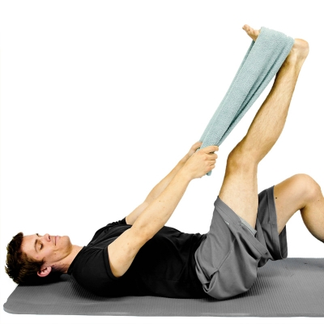
HAMSTRING STRETCH WITH TOWEL While lying down on your back, hook a towel or strap under your foot and draw up your leg until a stretch is felt along the backside of your leg. Keep your knee in a straightened position during the stretch. **At least twice per day, 3 is the goal** Repeat 5 Times Hold 10 Seconds Complete 1 Set Perform 3 Times a Day

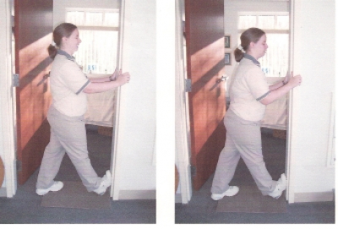
CALF DOORWAY STRETCH Place bottom of foot in doorway. To increase stretch lean body forward. At least twice per day, aiming for 3.
Repeat 5 Times Hold 10 Seconds Complete 1 Set Perform 3 Times a Day

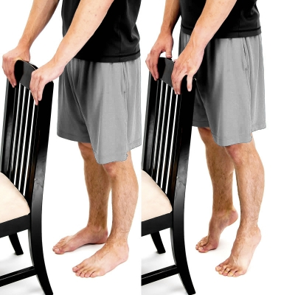
HEEL RAISES - CALF RAISES - While standing, raise up on your toes as you lift your heels off the ground.
Repeat 10 Times Hold 5 Seconds Complete 1 Set Perform 1 Times a Day

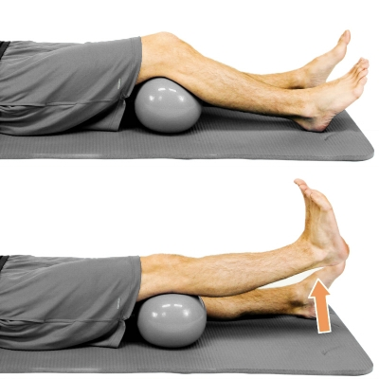
SHORT ARC QUAD - SAQ Place a rolled up towel or object under your knee and slowly straighten your knee as your raise up your foot. Lower back down and repeat. Repeat 10 Times Hold 5 Seconds Complete 1 Set Perform 1 Times a Day

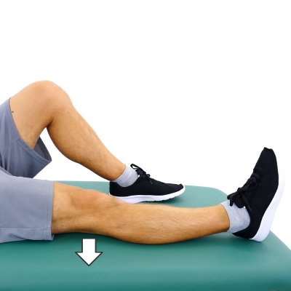
QUAD SETS - ISOMETRIC QUADS Sit down and straighten your leg and knee. Tighten your top thigh muscle to press the back of your knee downward. Hold this and then relax and repeat. Repeat 10 Times Hold 5 Seconds Complete 1 Set Perform 1 Times a Day

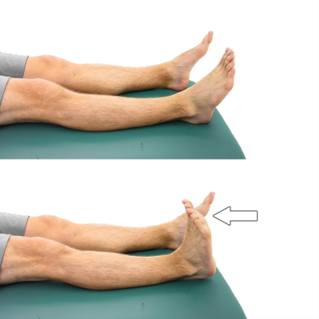
DORSIFLEXION - SUPINE While lying down on your back, bend your ankle to move your foot upwards or towards the direction of your knee as shown. Relax and repeat.
Repeat 10 Times Hold 5 Seconds Complete 1 Set Perform 1 Times a Day

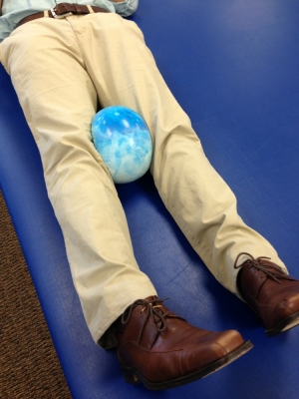
QUAD SET WITH BALL SQUEEZE Place a small ball or pillow between your knees. Contract your quads by pushing your knees down and then squeeze the ball concurrently.
Repeat 10 Times Hold 5 Seconds Complete 1 Set Perform 1 Times a Day

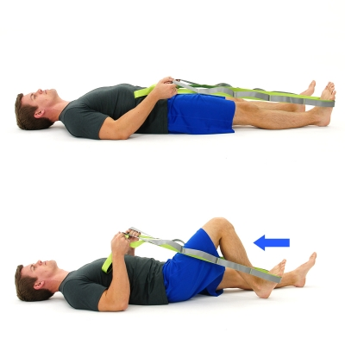
SUPINE HEEL SLIDES - STRETCH While lying on your back place a belt, towel, strap or bed sheet around your foot and start by pulling with your arms to bend your knee into a bent position until a gentle stretch is felt and hold this position. Then allow your knee to straighten back out to starting position and repeat.
Repeat 10 Times Hold 5 Seconds Complete 1 Set Perform 1 Times a Day

