ACL Repair Rehabilitation
Phase 3 (~Weeks 8-12)

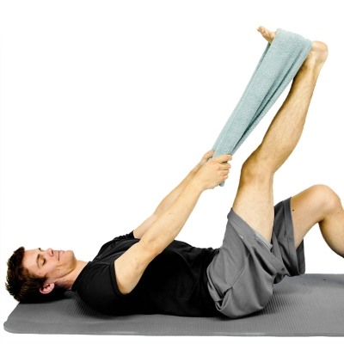
HAMSTRING STRETCH WITH TOWEL While lying down on your back, hook a towel or strap under your foot and draw up your leg until a stretch is felt along the backside of your leg. Keep your knee in a straightened position during the stretch. **At least twice per day, 3 is the goal** Repeat 5 Times Hold 10 Seconds Complete 1 Set Perform 3 Times a Day

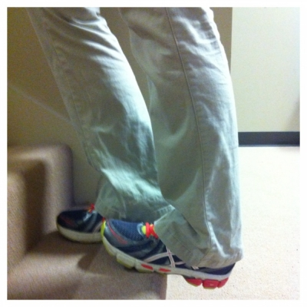
Calf Stretch on a Stair Standing on a stair so that the edge of the stair hits the midfoot, let one foot drop down below the stair so that a stretch is felt in the back of the lower leg. Hold and repeat on the opposite side.
Repeat 3 Times Hold 15 Seconds Perform 3 Times a Day

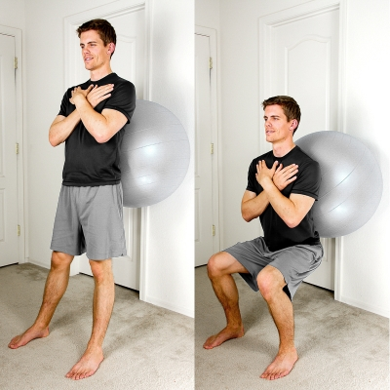
EXERCISE BALL - WALL SQUATS Start by standing up and leaning your low back up against an exercise ball on a wall. Your feet should be spread apart about shoulder width apart. Next, slowly bend your knees and lower your buttocks towards the floor. Knees should bend in line with the 2nd toe and not pass the front of the foot.
Repeat 10 Times Hold 5 Seconds Complete 2 Sets Perform 3 Times a Week

ELASTIC BAND - HIP INTERNAL ROTATION Start with an elastic band attached at your ankle from the side. Next, pull away from your other leg while keeping your thigh from moving across the table.
Repeat 10 Times Hold 5 Seconds Complete 2 Sets Perform 3 Times a Week

ELASTIC BAND - HIP EXTERNAL ROTATION Start with an elastic band attached at your ankle from the side. Next, pull towards your other leg while keeping your thigh from moving across the table.
Repeat 10 Times Hold 5 Seconds Complete 2 Sets Perform 3 Times a Week

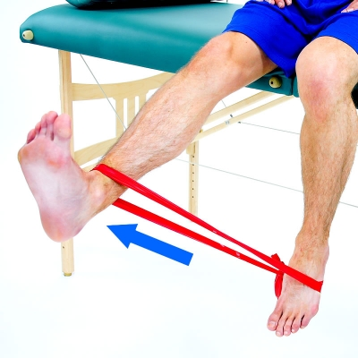
ELASTIC BAND - KNEE EXTENSION Attach a looped elastic band to your ankle and to the opposite foot. Next, draw your lower leg upwards to a straighten knee position while your other foot anchors the band.
Repeat 10 Times Hold 5 Seconds Complete 1 Set Perform 3 Times a Week

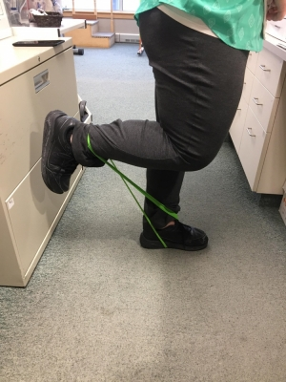
STANDING HAMSTRING CURL WITH BAND Standing with band around the arch of your foot of your non-affected leg and around the ankle of your affected leg. Keeping your knees tight together, slowly pull your heel toward your butt and slowly return to starting position. Avoid letting your knee come forward.
Repeat 10 Times Hold 5 Seconds Complete 1 Set Perform 3 Times a Week

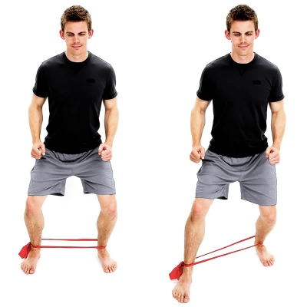
MONSTER WALK - ELASTIC BAND AT ANKLES Place a looped elastic band around both ankles. Next, bend your knees and step forward while keeping tension on the band the entire time. After taking several steps forward, reverse the direction taking steps back until you return to the starting position. Repeat.
Repeat 10 Times Hold 1 Second Complete 1 Set Perform 1 Times a Day

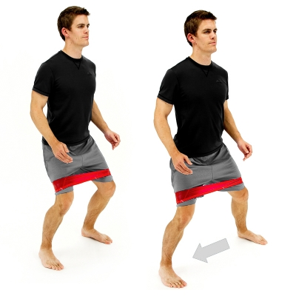
LATERAL MONSTER WALK - ELASTIC BAND AT THIGHS Place a looped elastic band around both thighs. Next, bend your knees and step to the side while keeping tension on the band the entire time. After taking sidesteps to the side in one direction, reverse the direction taking sidesteps until you return to the starting position. Repeat.
Repeat 10 Times Hold 1 Second Complete 1 Set Perform 1 Times a Day

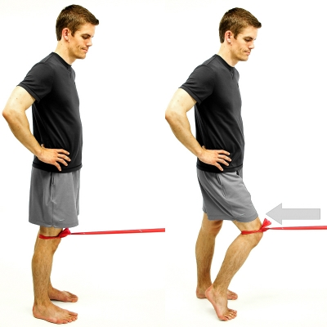
TERMINAL KNEE EXTENSION - TKE Start in a standing position with an elastic band attached above your knee and the other end tied with a knot and fixated behind a closed door or other anchor. The target knee should be partially bent with your toes touching the ground. Next, move your knee back towards a straightened position so that your heel touches the floor and you pull against the band.
Repeat 10 Times Hold 5 Seconds Complete 1 Set Perform 1 Times a Day

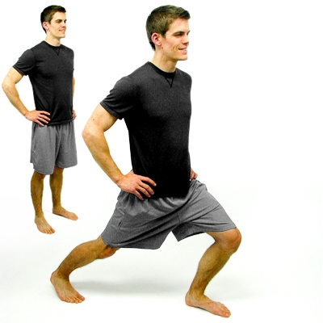
LUNGE Start by standing with feet shoulder-width-apart. Next, take a step forward and slightly out to the side and allow your front knee to bend. Your back knee may bend as well. Then, return to original position, or you may walk and take a step forward and repeat with the other leg. Keep your pelvis level and straight the entire time. Your front knee should bend in line with the 2nd toe and not pass the front of the foot.
Repeat 10 Times Hold 5 Seconds Complete 1 Set Perform 1 Times a Day

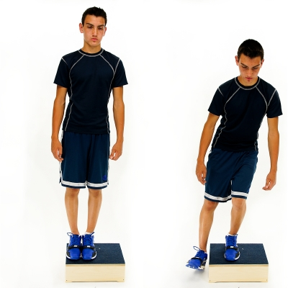
STEP DOWN - LATERAL Start with both feet on top of a step/box. Next, slowly lower the unaffected leg down off the side of the step/box to lightly touch the heel to the floor. Then return to the original position with both feet on the step/box. Maintain proper knee alignment: Knee in line with the 2nd toe and not passing in front of the toes.
Repeat 10 Times Hold 5 Seconds Complete 1 Set Perform 1 Times a Day

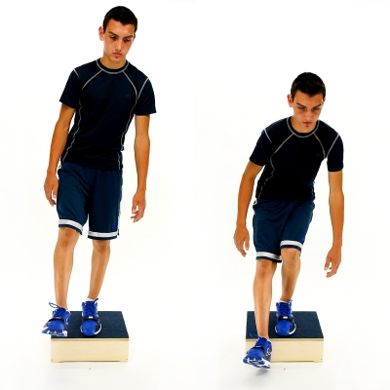
STEP DOWN - FORWARD Start with both feet on top of a step/box. Next, slowly lower the unaffected leg down foward off the step/box to lightly touch the heel to the floor. Then return to the original position with both feet on the step/box. Maintain proper knee alignment: Knee in line with the 2nd toe and not passing in front of the toes.
Repeat 10 Times Hold 5 Seconds Complete 1 Set Perform 1 Times a Day

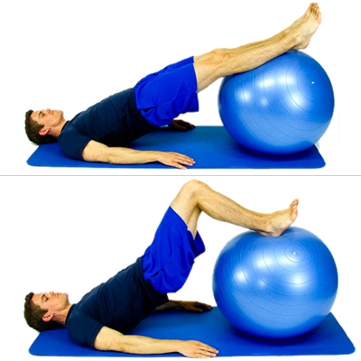
EXERCISE BALL - HAMSTRING CURLS While lying on the floor, place an exercise ball under the heels of your feet. Next, raise up your buttocks and then bend your knees to draw the ball towards your buttocks. Keep your buttocks elevated off the floor the whole time.
Repeat 10 Times Hold 5 Seconds Complete 1 Set Perform 1 Times a Day

