ACL Repair Rehabilitation
Phase 4 (Discharge)

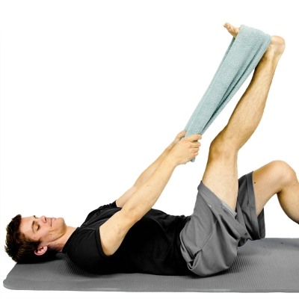
HAMSTRING STRETCH WITH TOWEL While lying down on your back, hook a towel or strap under your foot and draw up your leg until a stretch is felt along the backside of your leg. Keep your knee in a straightened position during the stretch. **At least twice per day, 3 is the goal** Repeat 5 Times Hold 10 Seconds Complete 1 Set Perform 3 Times a Day

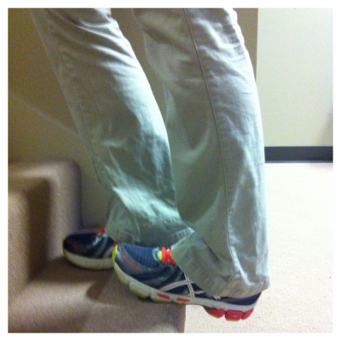
CALF STRETCH ON A STAIR Standing on a stair so that the edge of the stair hits the midfoot, let one foot drop down below the stair so that a stretch is felt in the back of the lower leg. Hold and repeat on the opposite side.
Repeat 3 Times Hold 15 Seconds Perform 3 Times a Day

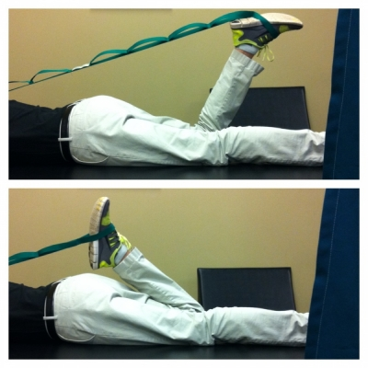
PRONE QUAD STRETCH Lie down flat on your stomach. Wrap a strap (belt, towel, dog leash) around the top of one of your feet and pull the strap across your opposite shoulder so that your knee starts to curl up to your body. Pull until a stretch is felt across the front of your thigh.
Repeat 5 Times Hold 30 Seconds Complete 1 Set Perform 1 Times a Day

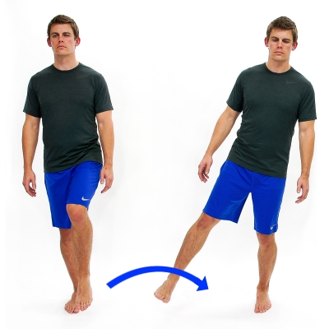
HOP STICK - LATERAL Stand on one leg and then hop to the side onto the other leg. Maintain your balance the entire time. Increase the difficulty by hoping to the side further and higher. Repeat 10 Times Hold 5 Seconds Complete 1 Set Perform 1 Times a Day

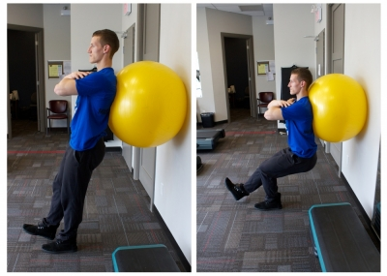
SINGLE LEG SQUAT Place a swiss ball between your back and the wall. Make sure your feet are forward enough that as you squat your knee will not go in front of your toes. Arms crossed, keep your elbows up and slowly squat down on one leg, controlled the entire way
Repeat 10 Times Hold 5 Seconds Complete 1 Set Perform 1 Times a Day

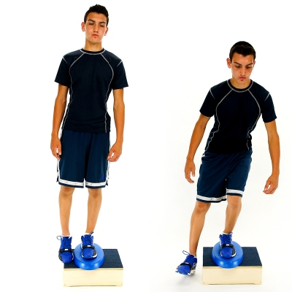
STEP DOWN - LATERAL - UNSTABLE Start with both feet on top of a step/box and on top of an unstable surface such as a foam pad. Next, slowly lower the unaffected leg off the side of the step/box to lightly touch the heel to the floor. Then return to the original position with both feet on the step/box. Maintain proper knee alignment: Knee in line with the 2nd toe and not passing in front of the toes.
Repeat 10 Times Hold 5 Seconds Complete 1 Set Perform 1 Times a Day

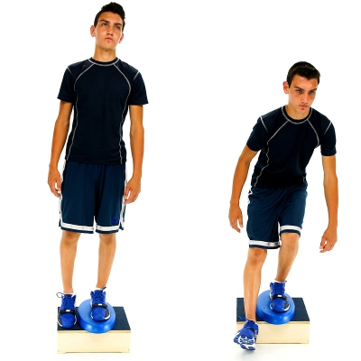
STEP DOWN - FORWARD - UNSTABLE Start with both feet on top of a step/box and on top of an unstable surface such as a foam pad. Next, slowly lower the unaffected leg down forward off the step/box to lightly touch the heel to the floor. Then return to the original position with both feet on the step/box. Maintain proper knee alignment: Knee in line with the 2nd toe and not passing in front of the toes.
Repeat 10 Times Hold 5 Seconds Complete 1 Set Perform 1 Times a Day

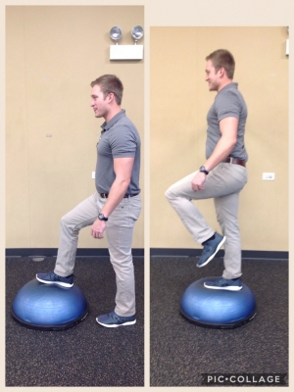
BOSU STEP UP TO BALANCE - FORWARD Step up on the BOSU forward with your right leg and balance on there for 2 seconds. Bring your right leg down. Maintain your balance.
Repeat 10 Times Hold 10 Seconds Complete 1 Set Perform 1 Times a Day

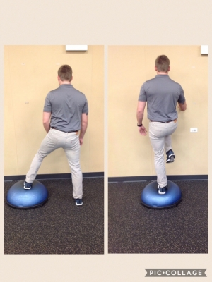
BOSU STEP UP TO BALANCE - LATERAL Facing the wall, step up on the BOSU with your right leg and balance for 2 seconds. Bring your right leg back down. Maintain your balance.
Repeat 10 Times Hold 10 Seconds Complete 1 Set Perform 1 Times a Day

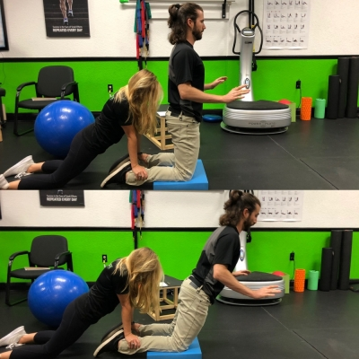
FULL NORDIC HAMSTRING CURL With both knees on the ground, have a partner hold the ankles down. Engage the core and slowly lower the torso to the ground. Focus on engaging hamstrings and using them to resistant the body weight as you lower towards the ground. HOLD HANDS OUT IN FRONT OF BODY TO CATCH YOUR FALL ONCE HAMSTRINGS GIVE OUT.
Repeat 10 Times Complete 1 Set Perform 1 Times a Day

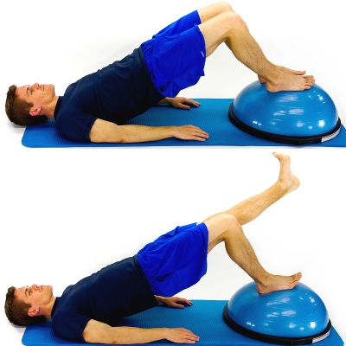
BOSU - BRIDGE SINGLE LEG While lying on your back with your feet planted on top of the Bosu and knees bent, lift up your buttocks and then straighten one knee in the air as shown. Next, perform on the other leg.
Repeat 10 Times Hold 5 Seconds Complete 1 Set Perform 1 Times a Day

